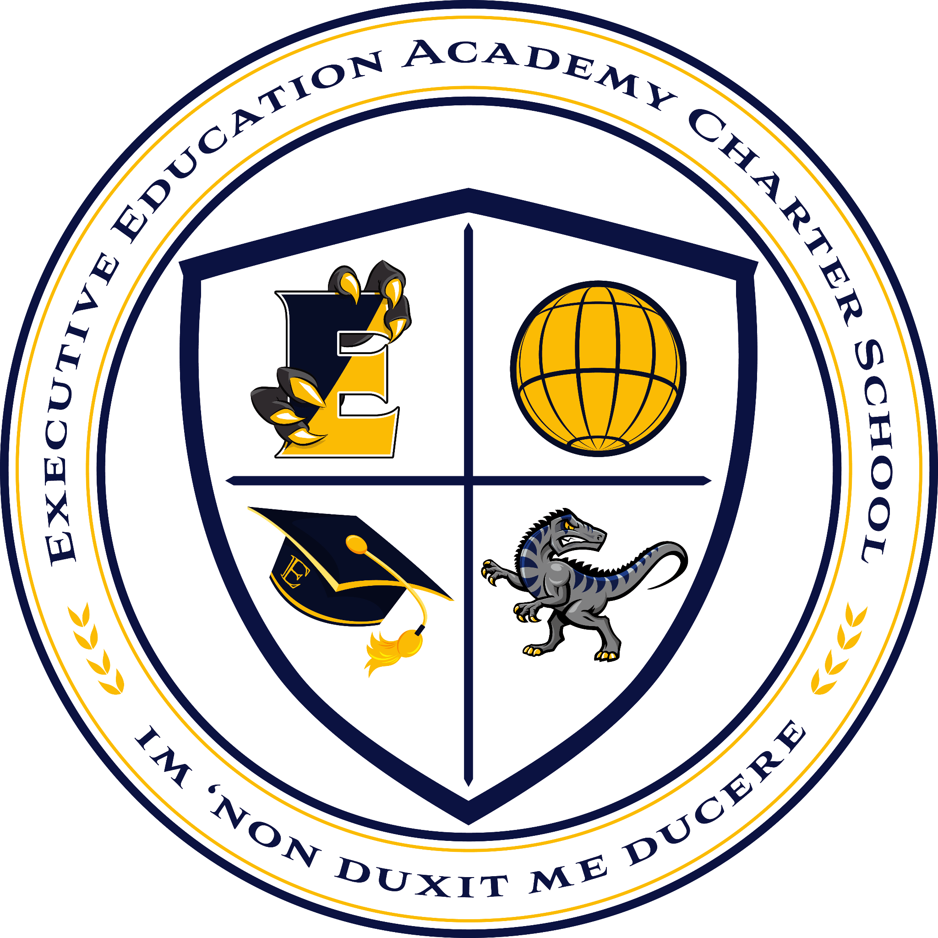
Executive Education Academy Charter School
555 Union Boulevard | Allentown, PA 18109
610-841-7044 | fax 610-841-7187 | www.ee-schools.org

2024-2025 High School Supply List

1. Notebooks with pockets or separate folders, one per class
2. Pens and pencils
3. Highlighters
4. A scientific calculator
5. A planner or agenda
6. A reusable water bottle
7. Index cards

