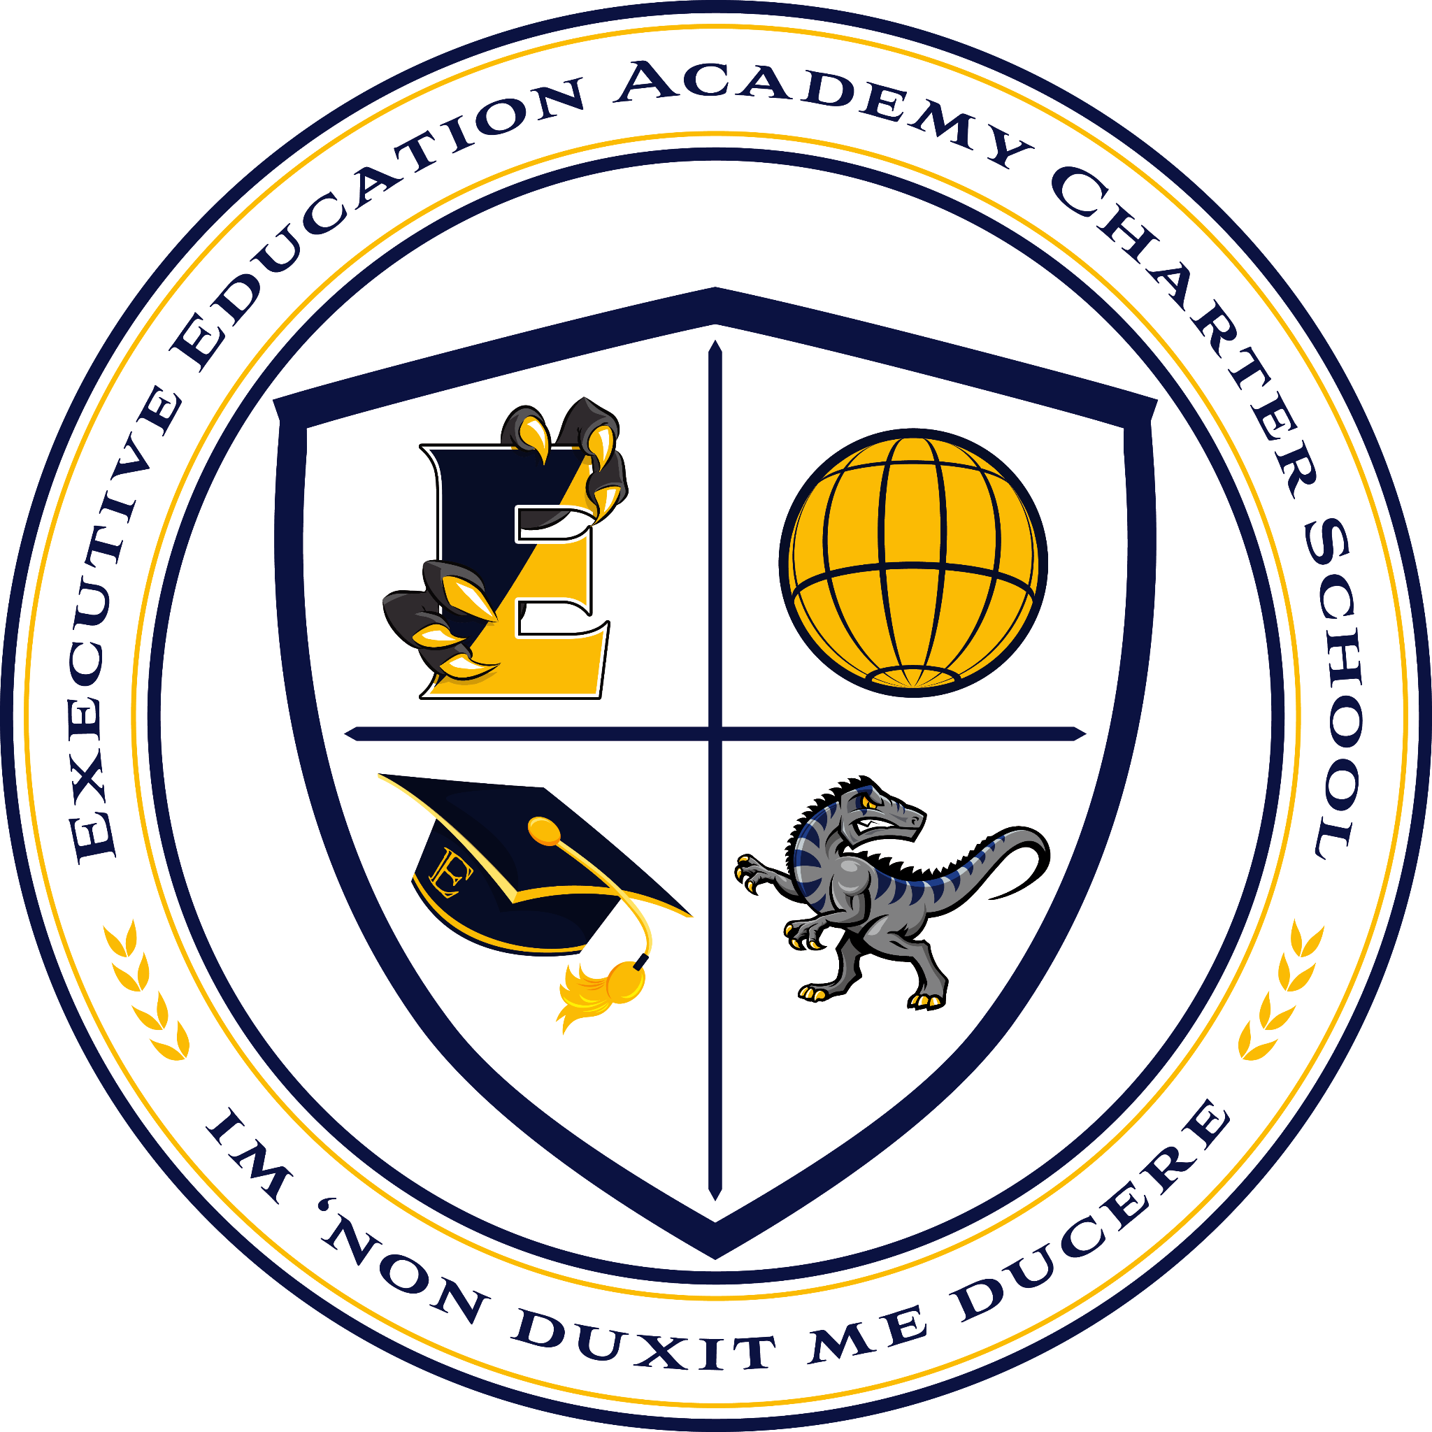
Executive Education Academy Charter School
555 Union Boulevard | Allentown, PA 18109
610-841-7044 | fax 610-841-7187 | www.ee-schools.org

High School Uniform

-White button down shirt
-Black or Khaki pants (no shorts or jeans)
-School tie (purchase in the main office)
-Sneakers or dress shoes (no crocs, heels, uggs, slides or slippers)
-If desired a school quarter zip* with the Executive logo (no other sweatshirts/coverings will be allowed)
*These are available through CSD for $35 starting August 7th

